HOME PAGE

<html>

<head>

<title> ONLINE BOOK STORE </title>

<link rel="stylesheet" href="style.css">

<link rel="stylesheet" href="https://stackpath.bootstrapcdn.com/bootstrap/4.3.1/css/bootstrap.min.css">

<link rel="stylesheet" href="https://stackpath.bootstrapcdn.com/font-awesome/4.7.0/css/font-awesome.min.css">

<script src="https://code.jquery.com/jquery-3.3.1.slim.min.js"></script>

<script src="https://cdnjs.cloudflare.com/ajax/libs/popper.js/1.14.7/umd/popper.min.js">

</script>

<script src="https://stackpath.bootstrapcdn.com/bootstrap/4.3.1/js/bootstrap.min.js"></script>

</title>

</head>

<body>

<!-----navigation bar---->

<section id="nav-bar">

<nav class="navbar navbar-expand-lg navbar-light">

<a class="navbar-brand" href="#top"><img src="img/logo.png"></a>

<button class="navbar-toggler" type="button" data-toggle="collapse" data-target="#navbarNav" aria-controls="navbarNav" aria-expanded="false" aria-label="Toggle navigation">

<span class="navbar-toggler-icon"></span>

</button>

<div class="collapse navbar-collapse" id="navbarNav">

<ul class="navbar-nav ml-auto">

<li class="nav-item">

<a class="nav-link" href="#"><i class="fa fa-home" aria-hidden="true"></i></a>

</li>

<li class="nav-item dropdown">

<a class="nav-link dropdown-toggle" href="#" data-toggle="dropdown">BOOKS</a>

<div class="dropdown-menu">

<a class="dropdown-item" href="file:///C:/Users/Laptop/Desktop/new/p1.html">ACTION AND ADVENTURE</a>

<a class="dropdown-item" href="file:///C:/Users/Laptop/Desktop/new/p2.html">AUTOBIOGRAPHY</a>

<a class="dropdown-item" href="file:///C:/Users/Laptop/Desktop/new/p3.html">DRAMA</a>

<a class="dropdown-item" href="file:///C:/Users/Laptop/Desktop/new/p4.html">HORROR</a>

<!--<a class="dropdown-item" href="#">MYSTERY</a>-->

</div>

</li>

<li class="nav-item dropdown">

<a class="nav-link dropdown-toggle" href="#" data-toggle="dropdown">NEW ARRIVALS</a>

<div class="dropdown-menu">

<a class="dropdown-item" href="#">RED RISING</a>

<a class="dropdown-item" href="#">BECOMING</a>

<a class="dropdown-item" href="#">CITY OF GLASS</a>

<a class="dropdown-item" href="#">THE GURDIANS</a>

<a class="dropdown-item" href="#">LITTLE WIERDS</a>

<a class="dropdown-item" href="#">THE STARLESS SEA</a>

</div>

</li>

<li class="nav-item">

<a class="nav-link" href="file:///C:/Users/Laptop/Desktop/new/login.htm">LOG IN</a>

</li>

<li class="nav-item">

<a class="nav-link" href="file:///C:/Users/Laptop/Desktop/new/file1111.html">SIGN IN</a>

</li>

<li class="nav-item">

<a class="nav-link" href="#"><i class="fa fa-shopping-cart" aria-hidden="true"></i></a>

</li>

<li class="nav-item">

<a class="nav-link" href="#contact">CONTACT US</a>

</li>

<!--

<li class="nav-item">

<a class="nav-link disabled" href="#" tabindex="-1" aria-disabled="true">Disabled</a>

</li>--->

</ul>

</div>

</nav>

</section>

<!----Slider---->

<div id="slider">

<div id="headerSlider" class="carousel slide" data-ride="carousel">

<ol class="carousel-indicators">

<li data-target="#headerSlider" data-slide-to="0" class="active"></li>

<li data-target="#headerSlider" data-slide-to="1"></li>

<li data-target="#headerSlider" data-slide-to="2"></li>

</ol>

<div class="carousel-inner">

<div class="carousel-item active">

<img src="img/a.jpg" class="d-block w-100">

</div>

<div class="carousel-item">

<img src="img/a2.jpg" class="d-block w-100">

</div>

<div class="carousel-item">

<img src="img/a3.jpg" class="d-block w-100">

</div>

</div>

<a class="carousel-control-prev" href="#headerSlider" role="button" data-slide="prev">

<span class="carousel-control-prev-icon" aria-hidden="true"></span>

<span class="sr-only">Previous</span>

</a>

<a class="carousel-control-next" href="#headerSlider" role="button" data-slide="next">

<span class="carousel-control-next-icon" aria-hidden="true"></span>

<span class="sr-only">Next</span>

</a>

</div>

</div>

<br>

<!----About---->

<section id="about">

<div class="container">

<div class="row">

<div class="col-md-12">

<h2 style="text-align: center;"> ABOUT US </h2>

<div class="about-content">

We offer you over many categories such as Children’s Books, Business & Economics, Indian Writing and Literature & Fiction.

Reading books is the favourite pastime of many people. If you’re bitten by the book-bug too, then there is a massive collection of books for you to read. From bestsellers to new & future releases, the choices are exhaustive.

From books for dummies, to textbooks for students, there are a wide variety of books. You can explore the young adults books store if you’re looking to gift a nice book to a teenager, where you can find books from the best-selling series.

Innumerable books are divided under various categories like action & adventure, business & economics, comics & mangas, crime, thriller & mystery, fiction, humour, and romance. You can browse by genre when you buy online making it more convenient for you to narrow down your choices. Then there are biographies and true accounts bestsellers as well. These books are available in different formats like hardcover, paperback, and board book.

When you shop online, there are hot pre-orders. You can easily secure that book you’ve always wanted to read, as the book will be delivered at your doorstep soon after its official release. You also have easy access to most of the new arrivals, with book descriptions that help you get an idea about the book without spoilers.

</div>

</div>

</div>

</div>

</section>

<br>

<!---Services-->

<section id="services">

<div class="container">

<h1>GENRES</h1>

<div class="row services">

<div class="col-md-3 text-center">

<h3>ACTION AND ADVENTURE</h3>

<p><h6> What's the best definition for the action adventure genre? Books in the action adventure genre not only have the action sequences seen in the action genre, but the plots continue into an adventure that takes the characters on a personal journey or to different geographical locations.</h6></p>

</div>

<div class="col-md-3 text-center">

<h3>AUTOBIOGRAPHY</h3>

<br>

<p><h6> An autobiography is a written account of the life of the writer. Autobiographical accounts are written in first person and may include important public life events as well as private affairs, personal reflections, and emotional reactions.

</h6></p>

</div>

<div class="col-md-3 text-center">

<h3>DRAMA</h3>

<br>

<p><h6> What's the best definition for the drama fiction genre? The drama genre is strongly based in a character, or characters, that are in conflict at a crucial moment in their lives. Most dramas revolve around families and often have tragic or painful resolutions</h6></p>

</div>

<div class="col-md-3 text-center">

<h3>HORROR</h3>

<br>

<p><h6> In literature, horror (pronounced hawr-er) is a genre of fiction whose purpose is to create feelings of fear, dread, repulsion, and terror in the audience—in other words, it develops an atmosphere of horror

</h6></p>

</div>

</div>

</div>

</section>

<!----Authors--->

<section id="team">

<div class="container">

<h1>FAMOUS AUTHORS</h1>

<div class="row">

<div class="col-md-3 profile-pic text-center">

<div class="img-box">

<img src="img/9a.jpg" class="img-responsive">

<ul>

<a href="https://www.instagram.com/authordanbrown/?hl=en">

<li><i class="fa fa-instagram" aria-hidden="true"></i></li>

</a>

<a href="https://twitter.com/authordanbrown?lang=en">

<li><i class="fa fa-twitter" aria-hidden="true"></i></li>

</a>

<a href="https://www.facebook.com/DanBrown/">

<li><i class="fa fa-facebook" aria-hidden="true"></i></li>

</a>

</ul>

</div>

<h2>Dan Brown</h2>

<h3>Thriller, adventure, mystery, conspiracy</h3>

</div>

<div class="col-md-3 profile-pic text-center">

<div class="img-box">

<img src="img/5a.jpg" class="img-responsive">

<ul>

<a href="https://www.instagram.com/explore/tags/arundhatiroy/">

<li><i class="fa fa-instagram" aria-hidden="true"></i></li>

</a>

<a href="https://twitter.com/hashtag/arundhatiroy?lang=en">

<li><i class="fa fa-twitter" aria-hidden="true"></i></li>

</a>

<a href="https://www.facebook.com/ArundhatiRoyAuthor/">

<li><i class="fa fa-facebook" aria-hidden="true"></i></li>

</a>

</ul>

</div>

<h2>Arundhati Roy</h2>

<h3>Fantasy</h3>

</div>

<div class="col-md-3 profile-pic text-center">

<div class="img-box">

<img src="img/8a.jpg" class="img-responsive">

<ul>

<a href="https://www.instagram.com/officialagathachristie/?hl=en">

<li><i class="fa fa-instagram" aria-hidden="true"></i></li>

</a>

<a href="https://twitter.com/agathachristie?ref_src=twsrc%5Egoogle%7Ctwcamp%5Eserp%7Ctwgr%5Eauthor">

<li><i class="fa fa-twitter" aria-hidden="true"></i></li>

</a>

<a href="https://www.facebook.com/OfficialAgathaChristie/">

<li><i class="fa fa-facebook" aria-hidden="true"></i></li>

</a>

</ul>

</div>

<h2>Agatha Christie</h2>

<h3>Murder mystery, thriller, crime fiction, detective, romance</h3>

</div>

<div class="col-md-3 profile-pic text-center">

<div class="img-box">

<img src="img/4a.jpg" class="img-responsive">

<ul>

<a href="https://www.instagram.com/explore/tags/jkrowling/?hl=en">

<li><i class="fa fa-instagram" aria-hidden="true"></i></li>

</a>

<a href="https://twitter.com/jk_rowling?lang=en">

<li><i class="fa fa-twitter" aria-hidden="true"></i></li>

</a>

<a href="https://www.facebook.com/JKRowling/">

<li><i class="fa fa-facebook" aria-hidden="true"></i></li>

</a>

</ul>

</div>

<h2>J.K.Rowling</h2>

<h3>Fantasy</h3>

</div>

</div>

</div>

</section>

<!---Get In Touch--->

<section id="contact">

<div class="container">

<h1>GET IN TOUCH</h1>

<div class="row">

<div class="col-md-6">

<form class="contact-form">

<div class="form-group">

<input type="text" class="form-control" placeholder="Your Name">

</div>

<div class="form-group">

<input type="number" class="form-control" placeholder="Phone No.">

</div>

<div class="form-group">

<input type="email" class="form-control" placeholder="Email Id">

</div>

<div class="form-group">

<textarea class=" form-control" rows="4" placeholder="Message">

</textarea>

</div>

<button type="submit" class="btn btn-primary">SEND MESSAGE

</button>

</form>

</div>

<!-- <div class="col-md-6 contact-info">

<div class="follow"><b>Address:</b><i class="fa fa-map-marker"></i> XYZ Road,Mumbai, IN

</div>

<div class="follow"><b>Phone:</b><i class="fa fa-phone"></i>+1 1234567890

</div>

<div class="follow"><b>Email:</b><i class="fa fa-envelope-o"></i>example@website.com

</div>

<div class="follow"><label><b>Get Social:</b></label>

<a href="#"><i class="fa fa-facebook"></i></a>

<a href="#"><i class="fa fa-youtube-play"></i></a>

<a href="#"><i class="fa fa-twitter"></i></a>

<a href="#"><i class="fa fa-google-plus"></i></a>

</div>

</div>-->

</div>

</div>

</section>

<!----Footer--->

<section id="footer">

<div class="container">

<span style="float: left">

<p> Contact Us: 9765340232|9345210876<br>

Address: XYZ road,Mumbai, India

<br>

Email id: pickabook@gmail.com<br>

</p>

</span>

<span style="float: right">

<p> Follow us <br>

<i class="fa fa-facebook-official" aria-hidden="true"></i>

<i class="fa fa-twitter" aria-hidden="true"></i>

<i class="fa fa-instagram" aria-hidden="true"></i>

<i class="fa fa-pinterest" aria-hidden="true"></i>

<i class="fa fa-google-plus" aria-hidden="true"></i>

</p>

</span>

</div>

</section>

<!---Footer End--->

<script src="js/smooth-scroll.js"></script>

<script>

var scroll = new SmoothScroll('a[href*="#"]');

</script>

</body>

</html>

HOME PAGE CSS

*

{

margin: 0;

padding: 0;

}

/*-------Navigation------*/

#nav-bar

{

position: sticky;

top: 0;

z-index:10;

}

.navbar-brand img

{

height: 100px;

padding-left: 30px;

}

.navbar-nav li

{

padding: 0 10px;

}

.navbar-nav li a

{

float: right;

text-align: : left;

}

#nav-bar ul li a:hover

{

color: #0000ff!important;

}

.navbar

{

background: #fff;

}

.navbar-toggler

{

border: none!important;

}

.nav-link

{

color: #555!important;

font-weight: 600;

font-size: : 16px;

}

/*---slider--*/

#slider

{

width: 100%

}

.carousel-caption

{

top: 50%;

transform: transalteY(-50%);

bottom: initial!important;

}

.carousel-caption h5

{

color: #ffa500;

font-size: 42px;

}

/*---About--*/

padding-top: 50px;

padding-bottom: 50px;

color: #555;

}

#about .btn

{

margin-top: 20px;

margin-bottom: 30px;

}

.about-content

{

padding-top: 15px;

}

/*----Services----*/

#services

{

background-image: linear-gradient(rgba(0,0,0,0.8),rgba(0,0,0,0.8)),url(img/1.jpg);

background-size: cover;

background-position: center;

color: #efefef !important;

background-attachment: fixed;

padding-top: 50px;

padding-bottom: 50px;

}

#services h1

{

text-align: center;

color: #efefef !important;

padding-bottom: 10px;

}

#services h1::after

{

content: '';

background: #efefef;

display:block;

height: 3px;

width: 170px;

margin:20px auto 5px;

}

.services

{

margin top: 40px;

}

#services p

{

font-size: 14px;

margin-top: 20px;

color: #ccc;

}

.services .col-md-3:hover

{

background: #007bff;

transition: 0.7s;

cursor: pointer;

}

/*---team memebers*/

#team

{

padding-top: 50px;

padding-bottom: 50px;

color: #555;

}

h1

{

text-align:center;

color: #555 !important;

padding-bottom: 10px;

}

h1::after

{

content: '';

background: #007bff;

display: block;

height: 3px;

width: 170px;

margin: 20px auto 5px;

}

.profile-pic

{

margin-top: 25px;

}

.profile-pic .img-box

{

opacity: 1;

display: block;

position: relative;

}

.profile-pic .img-box img

{

filter: grayscale(1);

}

.profile-pic .img-box img:hover

{

filter: grayscale(0);

cursor: pointer;

}

.profile-pic h2

{

font-size: 22px;

font-weight: bold;

margin-top: 15px;

color: #007bff !important;

}

.profile-pic h3

{

font-size: 15px;

font-weight: bold;

margin: 15px;

}

#team .fa

{

height: 25px;

width: 25px;

color: #007bff !important;

background: #fff;

padding: 4px;

border-radius: 50%;

}

.img-box ul

{

padding: 15px;

position: absolute;;

z-index: 2;

bottom: 0;

left: 50%;

transform: translateX(-50%);

opacity: 0;

}

.img-box ul li

{

padding: 5px;

display: inline-block;

}

.img-box:hover ul

{

opacity: 1;

}

.img-box ul, .img-box ul li

{

transition: 0.5s;

}

/*----Get In Touch---*/

#contact

{

background: #efefef;

padding-top: 40px;

padding-bottom: 40px;

color: #777;

}

.contact form

{

padding: 15px;

}

.form-control

{

border-radius: 0 !important;

border: none !important;

}

::placeholder

{

color: #999 !important;

}

.follow

{

background: #fff;

padding: 10px;

margin: 10px;

}

.contact-info

{

margin: 10px;

color: #007bff;

font-weight: bold;

}

/*----footer---*/

#footer

{

background: #333;

color: #fff;

padding: 85px;

}

.fa-facebook-official

{

margin: 3px;

color: blue;

}

.fa-twitter

{

margin: 3px;

color: blue;

}

.fa-instagram

{

margin: 3px;

color: blue;

}

.fa-pinterest

{

margin: 3px;

color: blue;

}

.fa-google-plus

{

margin: 3px;

color: blue;

}

LOG IN

<!DOCTYPE html>

<html>

<head>

<meta charset="utf-8">

<title>Log In</title>

<link rel="stylesheet" href="log.css">

</head>

<body>

<form>

<div class="login-box">

<h1>Login</h1>

<div class="textbox">

<i class="fa fa-user" aria-hidden="true"></i>

<input type="text" placeholder="Enter Username" name="uname" required>

</div>

<div class="textbox">

<i class="fa fa-lock" aria-hidden="true"></i>

<input type="password" placeholder="Password" name="" value="">

</div>

<button type="submit">Login</button>

<div class="container" style="text-decoration: none;" >

<span ><a href="#"><br>Forgot password?</a><br><br><a>New User?</a><a href="file:///C:/Users/Laptop/Desktop/new/file1111.html">Register</a></span>

</div>

</form>

</body>

</html>

LOG IN CSS

@import "https://stackpath.bootstrapcdn.com/font-awesome/4.7.0/css/font-awesome.min.css";

body

{

margin: 0;

padding: 0;

font-family: sans-serif;

background: url(img/2.jpg);

background-repeat: no-repeat;

background-size: cover;

}

form {border: 3px solid #f1f1f1;}

.login-box

{

width: 280px;

border: 3px solid black;

position: absolute;

top: 50%;

left: 50%;

transform: translate(-50%,-50%);

color: white;

-webkit-box-shadow: 1px 15px 25px 16px rgba(0,0,0,0.75);

-moz-box-shadow: 1px 15px 25px 16px rgba(0,0,0,0.75);

box-shadow: 1px 15px 25px 16px rgba(0,0,0,0.75);

padding: 3% ;

}

.login-box h1

{

float: left;

font-size: 40px;

border-bottom: 6px solid #4caf50;

margin-bottom: 50px;

padding: 13px 0;

}

.textbox

{

width: 100%;

overflow: hidden;

font-size: 20px;

padding: 8px 0;

margin: 8px 0;

border-bottom: 1px solid #4caf50;

}

button {

background-color: #4CAF50;

color: white;

padding: 14px 20px;

margin: 8px 0;

border: none;

cursor: pointer;

width: 100%;

}

.textbox i

{

width: 26px;

float: left;

text-align: center;

}

.textbox input

{

/*border: none;

outline: none;*/

background-color: white ;

color: white;

font-size: 18px;

width: 80%;

float: left;

margin: 0 10px;

}

.btn

{

width: 100%;

background: none;

color: white;

padding: 5px;

border: 2px solid #4caf50;

font-size: 18px;

cursor: pointer;

margin: 12px 0;

}

SIGN IN

<!DOCTYPE html>

<html>

<head>

<title>Sign In</title>

<link rel="stylesheet" href="sign.css">

</head>

<body>

<div class="sign-up-form">

<h1> Sign Up now</h1>

<img src="new/img/p0.png">

<form>

<input type="text" class="input-box" placeholder="Your Name">

<input type="date" class="input-box" placeholder="Your date of birth">

<input type="email" class="input-box" placeholder="Your Email">

<input type="password" class="input-box" placeholder="Your Password">

<p>

<span>

<input type="checkbox"></span>

I agree to the terms of services </p>

<button type="button" class="signup-btn">Sign up</button>

<hr>

<p> Do you have an account? <a href="file:///C:/Users/Laptop/Desktop/new/login.htm#">Log In</a> </p>

</form>

</div>

</body>

</html>

SIGN IN CSS

body

{

margin: 0;

padding: 0;

font-family: sans-serif;

background-image: url(img/b2.jpg);

background-size: cover;

background-position: center;

}

.sign-up-form

{

width: 300px;

box-shadow: 0 0 3px 0 rgba(0,0,0,0.3);

background: #fff;

padding: 20px;

margin: 3% auto 0;

text-align:center;

-webkit-box-shadow: 1px 15px 25px 50px rgba(0,0,0,0.75);

-moz-box-shadow: 1px 15px 25px 50px rgba(0,0,0,0.75);

box-shadow: 1px 15px 25px 50px rgba(0,0,0,0.75);

}

.sign-up-form h1

{

color: #1c8adb;

margin-bottom: 30px;

}

.input-box

{

border-radius: 20px;

padding: 10px;

margin: 10px 0;

width: 90%;

border: 1px solid #999;

outline: none;

}

button

{

color: #fff;

width: 100%;

padding: 10px;

border-radius: 20px;

font-size: 15px;

margin: 10px 0;

border: none;

outline: none;

cursor: pointer;

}

.signup-btn

{

background-color: #1c8adb;

}

a

{

text-decoration: none;

}

hr

{

margin-top: 20px;

width: 80%;

}

.or

{

background: #fff;

width: 30px;

margin: -19px auto 10px;

}

img

{

width: 70px;

margin-top: -50px;

}

PAGE 1

<!DOCTYPE html>

<html>

<title>W3.CSS Template</title>

<meta charset="UTF-8">

<meta name="viewport" content="width=device-width, initial-scale=1">

<link rel="stylesheet" href="https://www.w3schools.com/w3css/4/w3.css">

<link rel="stylesheet" href="https://fonts.googleapis.com/css?family=Roboto">

<link rel="stylesheet" href="https://fonts.googleapis.com/css?family=Montserrat">

<link rel="stylesheet" href="https://cdnjs.cloudflare.com/ajax/libs/font-awesome/4.7.0/css/font-awesome.min.css">

<style>

.w3-sidebar a {font-family: "Roboto", sans-serif}

body,h1,h2,h3,h4,h5,h6,.w3-wide {font-family: "Montserrat", sans-serif;}

.w3-content

{

}

</style>

<body class="w3-content" style="margin-top: 30px" >

<!-- Product grid -->

<div class="w3-row ">

<div class="w3-col l3 s6">

<div class="w3-container">

<img src="img/q1.jpg" width=200>

<p>The Da Vinci Code by Dan Brown<br><b>Rs.250</b></p>

</div>

<div class="w3-container">

<img src="img/q2.jpg" width=200>

<p>The Lightning Thief by Rick Riordan<br><b>Rs.200</b></p>

</div>

</div>

<div class="w3-col l3 s6">

<div class="w3-container">

<div class="w3-display-container">

<img src="img/q5.jpg" width=230>

</div>

<p>The HUNGER GAMES by Suzanne Collins<br><b>Rs.300</b></p>

</div>

<div class="w3-container">

<img src="img/q4.jpg" width=200>

<p>INSURGENT by VERONICA ROTH<br><b>Rs.199</b></p>

</div>

</div>

<div class="w3-col l3 s6">

<div class="w3-container">

<img src="img/q3.jpg" width=245>

<p>The Maze Runner by James Dashner<br><b>Rs.249</b></p>

</div>

<div class="w3-container">

<div class="w3-display-container">

<img src="img/z1.jpg" width=200>

</div>

<p>The Immortals of Meluha by Amish<br><b>Rs.399</b></p>

</div>

</div>

<div class="w3-col l3 s6">

<div class="w3-container">

<img src="img/z2.png" width=200>

<p>The Long Drive Home by Rishad Saam Mehta<br><b>Rs.149</b></p>

</div>

<div class="w3-container">

<img src="img/z3.jpg" width=200>

<p>11 Hours by Daniel Paul Singh<br><b>Rs.299</b></p>

</div>

</div>

</div>

</body>

</html>

PAGE 2

<html>

<head>

<title> ONLINE BOOK STORE </title>

<link rel="stylesheet" href="style.css">

<link rel="stylesheet" href="https://stackpath.bootstrapcdn.com/bootstrap/4.3.1/css/bootstrap.min.css">

<link rel="stylesheet" href="https://stackpath.bootstrapcdn.com/font-awesome/4.7.0/css/font-awesome.min.css">

<script src="https://code.jquery.com/jquery-3.3.1.slim.min.js"></script>

<script src="https://cdnjs.cloudflare.com/ajax/libs/popper.js/1.14.7/umd/popper.min.js">

</script>

<script src="https://stackpath.bootstrapcdn.com/bootstrap/4.3.1/js/bootstrap.min.js"></script>

</title>

</head>

<body>

<!-----navigation bar---->

<section id="nav-bar">

<nav class="navbar navbar-expand-lg navbar-light">

<a class="navbar-brand" href="#top"><img src="img/logo.png"></a>

<button class="navbar-toggler" type="button" data-toggle="collapse" data-target="#navbarNav" aria-controls="navbarNav" aria-expanded="false" aria-label="Toggle navigation">

<span class="navbar-toggler-icon"></span>

</button>

<div class="collapse navbar-collapse" id="navbarNav">

<ul class="navbar-nav ml-auto">

<li class="nav-item">

<a class="nav-link" href="#"><i class="fa fa-home" aria-hidden="true"></i></a>

</li>

<li class="nav-item dropdown">

<a class="nav-link dropdown-toggle" href="#" data-toggle="dropdown">BOOKS</a>

<div class="dropdown-menu">

<a class="dropdown-item" href="file:///C:/Users/Laptop/Desktop/new/p1.html">ACTION AND ADVENTURE</a>

<a class="dropdown-item" href="file:///C:/Users/Laptop/Desktop/new/p2.html">AUTOBIOGRAPHY</a>

<a class="dropdown-item" href="file:///C:/Users/Laptop/Desktop/new/p3.html">DRAMA</a>

<a class="dropdown-item" href="file:///C:/Users/Laptop/Desktop/new/p4.html">HORROR</a>

<!--<a class="dropdown-item" href="#">MYSTERY</a>-->

</div>

</li>

<li class="nav-item dropdown">

<a class="nav-link dropdown-toggle" href="#" data-toggle="dropdown">NEW ARRIVALS</a>

<div class="dropdown-menu">

<a class="dropdown-item" href="#">RED RISING</a>

<a class="dropdown-item" href="#">BECOMING</a>

<a class="dropdown-item" href="#">CITY OF GLASS</a>

<a class="dropdown-item" href="#">THE GURDIANS</a>

<a class="dropdown-item" href="#">LITTLE WIERDS</a>

<a class="dropdown-item" href="#">THE STARLESS SEA</a>

</div>

</li>

<li class="nav-item">

<a class="nav-link" href="file:///C:/Users/Laptop/Desktop/new/login.htm">LOG IN</a>

</li>

<li class="nav-item">

<a class="nav-link" href="file:///C:/Users/Laptop/Desktop/new/file1111.html">SIGN IN</a>

</li>

<li class="nav-item">

<a class="nav-link" href="#"><i class="fa fa-shopping-cart" aria-hidden="true"></i></a>

</li>

<li class="nav-item">

<a class="nav-link" href="#contact">CONTACT US</a>

</li>

<!--

<li class="nav-item">

<a class="nav-link disabled" href="#" tabindex="-1" aria-disabled="true">Disabled</a>

</li>--->

</ul>

</div>

</nav>

</section>

<!----Slider---->

<div id="slider">

<div id="headerSlider" class="carousel slide" data-ride="carousel">

<ol class="carousel-indicators">

<li data-target="#headerSlider" data-slide-to="0" class="active"></li>

<li data-target="#headerSlider" data-slide-to="1"></li>

<li data-target="#headerSlider" data-slide-to="2"></li>

</ol>

<div class="carousel-inner">

<div class="carousel-item active">

<img src="img/a.jpg" class="d-block w-100">

</div>

<div class="carousel-item">

<img src="img/a2.jpg" class="d-block w-100">

</div>

<div class="carousel-item">

<img src="img/a3.jpg" class="d-block w-100">

</div>

</div>

<a class="carousel-control-prev" href="#headerSlider" role="button" data-slide="prev">

<span class="carousel-control-prev-icon" aria-hidden="true"></span>

<span class="sr-only">Previous</span>

</a>

<a class="carousel-control-next" href="#headerSlider" role="button" data-slide="next">

<span class="carousel-control-next-icon" aria-hidden="true"></span>

<span class="sr-only">Next</span>

</a>

</div>

</div>

<br>

<!----About---->

<section id="about">

<div class="container">

<div class="row">

<div class="col-md-12">

<h2 style="text-align: center;"> ABOUT US </h2>

<div class="about-content">

We offer you over many categories such as Children’s Books, Business & Economics, Indian Writing and Literature & Fiction.

Reading books is the favourite pastime of many people. If you’re bitten by the book-bug too, then there is a massive collection of books for you to read. From bestsellers to new & future releases, the choices are exhaustive.

From books for dummies, to textbooks for students, there are a wide variety of books. You can explore the young adults books store if you’re looking to gift a nice book to a teenager, where you can find books from the best-selling series.

Innumerable books are divided under various categories like action & adventure, business & economics, comics & mangas, crime, thriller & mystery, fiction, humour, and romance. You can browse by genre when you buy online making it more convenient for you to narrow down your choices. Then there are biographies and true accounts bestsellers as well. These books are available in different formats like hardcover, paperback, and board book.

When you shop online, there are hot pre-orders. You can easily secure that book you’ve always wanted to read, as the book will be delivered at your doorstep soon after its official release. You also have easy access to most of the new arrivals, with book descriptions that help you get an idea about the book without spoilers.

</div>

</div>

</div>

</div>

</section>

<br>

<!---Services-->

<section id="services">

<div class="container">

<h1>GENRES</h1>

<div class="row services">

<div class="col-md-3 text-center">

<h3>ACTION AND ADVENTURE</h3>

<p><h6> What's the best definition for the action adventure genre? Books in the action adventure genre not only have the action sequences seen in the action genre, but the plots continue into an adventure that takes the characters on a personal journey or to different geographical locations.</h6></p>

</div>

<div class="col-md-3 text-center">

<h3>AUTOBIOGRAPHY</h3>

<br>

<p><h6> An autobiography is a written account of the life of the writer. Autobiographical accounts are written in first person and may include important public life events as well as private affairs, personal reflections, and emotional reactions.

</h6></p>

</div>

<div class="col-md-3 text-center">

<h3>DRAMA</h3>

<br>

<p><h6> What's the best definition for the drama fiction genre? The drama genre is strongly based in a character, or characters, that are in conflict at a crucial moment in their lives. Most dramas revolve around families and often have tragic or painful resolutions</h6></p>

</div>

<div class="col-md-3 text-center">

<h3>HORROR</h3>

<br>

<p><h6> In literature, horror (pronounced hawr-er) is a genre of fiction whose purpose is to create feelings of fear, dread, repulsion, and terror in the audience—in other words, it develops an atmosphere of horror

</h6></p>

</div>

</div>

</div>

</section>

<!----Authors--->

<section id="team">

<div class="container">

<h1>FAMOUS AUTHORS</h1>

<div class="row">

<div class="col-md-3 profile-pic text-center">

<div class="img-box">

<img src="img/9a.jpg" class="img-responsive">

<ul>

<a href="https://www.instagram.com/authordanbrown/?hl=en">

<li><i class="fa fa-instagram" aria-hidden="true"></i></li>

</a>

<a href="https://twitter.com/authordanbrown?lang=en">

<li><i class="fa fa-twitter" aria-hidden="true"></i></li>

</a>

<a href="https://www.facebook.com/DanBrown/">

<li><i class="fa fa-facebook" aria-hidden="true"></i></li>

</a>

</ul>

</div>

<h2>Dan Brown</h2>

<h3>Thriller, adventure, mystery, conspiracy</h3>

</div>

<div class="col-md-3 profile-pic text-center">

<div class="img-box">

<img src="img/5a.jpg" class="img-responsive">

<ul>

<a href="https://www.instagram.com/explore/tags/arundhatiroy/">

<li><i class="fa fa-instagram" aria-hidden="true"></i></li>

</a>

<a href="https://twitter.com/hashtag/arundhatiroy?lang=en">

<li><i class="fa fa-twitter" aria-hidden="true"></i></li>

</a>

<a href="https://www.facebook.com/ArundhatiRoyAuthor/">

<li><i class="fa fa-facebook" aria-hidden="true"></i></li>

</a>

</ul>

</div>

<h2>Arundhati Roy</h2>

<h3>Fantasy</h3>

</div>

<div class="col-md-3 profile-pic text-center">

<div class="img-box">

<img src="img/8a.jpg" class="img-responsive">

<ul>

<a href="https://www.instagram.com/officialagathachristie/?hl=en">

<li><i class="fa fa-instagram" aria-hidden="true"></i></li>

</a>

<a href="https://twitter.com/agathachristie?ref_src=twsrc%5Egoogle%7Ctwcamp%5Eserp%7Ctwgr%5Eauthor">

<li><i class="fa fa-twitter" aria-hidden="true"></i></li>

</a>

<a href="https://www.facebook.com/OfficialAgathaChristie/">

<li><i class="fa fa-facebook" aria-hidden="true"></i></li>

</a>

</ul>

</div>

<h2>Agatha Christie</h2>

<h3>Murder mystery, thriller, crime fiction, detective, romance</h3>

</div>

<div class="col-md-3 profile-pic text-center">

<div class="img-box">

<img src="img/4a.jpg" class="img-responsive">

<ul>

<a href="https://www.instagram.com/explore/tags/jkrowling/?hl=en">

<li><i class="fa fa-instagram" aria-hidden="true"></i></li>

</a>

<a href="https://twitter.com/jk_rowling?lang=en">

<li><i class="fa fa-twitter" aria-hidden="true"></i></li>

</a>

<a href="https://www.facebook.com/JKRowling/">

<li><i class="fa fa-facebook" aria-hidden="true"></i></li>

</a>

</ul>

</div>

<h2>J.K.Rowling</h2>

<h3>Fantasy</h3>

</div>

</div>

</div>

</section>

<!---Get In Touch--->

<section id="contact">

<div class="container">

<h1>GET IN TOUCH</h1>

<div class="row">

<div class="col-md-6">

<form class="contact-form">

<div class="form-group">

<input type="text" class="form-control" placeholder="Your Name">

</div>

<div class="form-group">

<input type="number" class="form-control" placeholder="Phone No.">

</div>

<div class="form-group">

<input type="email" class="form-control" placeholder="Email Id">

</div>

<div class="form-group">

<textarea class=" form-control" rows="4" placeholder="Message">

</textarea>

</div>

<button type="submit" class="btn btn-primary">SEND MESSAGE

</button>

</form>

</div>

<!-- <div class="col-md-6 contact-info">

<div class="follow"><b>Address:</b><i class="fa fa-map-marker"></i> XYZ Road,Mumbai, IN

</div>

<div class="follow"><b>Phone:</b><i class="fa fa-phone"></i>+1 1234567890

</div>

<div class="follow"><b>Email:</b><i class="fa fa-envelope-o"></i>example@website.com

</div>

<div class="follow"><label><b>Get Social:</b></label>

<a href="#"><i class="fa fa-facebook"></i></a>

<a href="#"><i class="fa fa-youtube-play"></i></a>

<a href="#"><i class="fa fa-twitter"></i></a>

<a href="#"><i class="fa fa-google-plus"></i></a>

</div>

</div>-->

</div>

</div>

</section>

<!----Footer--->

<section id="footer">

<div class="container">

<span style="float: left">

<p> Contact Us: 9765340232|9345210876<br>

Address: XYZ road,Mumbai, India

<br>

Email id: pickabook@gmail.com<br>

</p>

</span>

<span style="float: right">

<p> Follow us <br>

<i class="fa fa-facebook-official" aria-hidden="true"></i>

<i class="fa fa-twitter" aria-hidden="true"></i>

<i class="fa fa-instagram" aria-hidden="true"></i>

<i class="fa fa-pinterest" aria-hidden="true"></i>

<i class="fa fa-google-plus" aria-hidden="true"></i>

</p>

</span>

</div>

</section>

<!---Footer End--->

<script src="js/smooth-scroll.js"></script>

<script>

var scroll = new SmoothScroll('a[href*="#"]');

</script>

</body>

</html>

PAGE 3

<!DOCTYPE html>

<html>

<title>W3.CSS Template</title>

<meta charset="UTF-8">

<meta name="viewport" content="width=device-width, initial-scale=1">

<link rel="stylesheet" href="https://www.w3schools.com/w3css/4/w3.css">

<link rel="stylesheet" href="https://fonts.googleapis.com/css?family=Roboto">

<link rel="stylesheet" href="https://fonts.googleapis.com/css?family=Montserrat">

<link rel="stylesheet" href="https://cdnjs.cloudflare.com/ajax/libs/font-awesome/4.7.0/css/font-awesome.min.css">

<style>

.w3-sidebar a {font-family: "Roboto", sans-serif}

body,h1,h2,h3,h4,h5,h6,.w3-wide {font-family: "Montserrat", sans-serif;}

.w3-content

{

}

</style>

<body class="w3-content" style="margin-top: 30px" >

<!-- Product grid -->

<div class="w3-row ">

<div class="w3-col l3 s6">

<div class="w3-container">

<img src="img/n1.jpg" width=185>

<p>The Girl on the Train by Paula Hawkins<br><b>Rs.150</b></p>

</div>

<div class="w3-container">

<img src="img/n2.jpg" width=200>

<p>The Fault in Our Stars by John Green<br><b>Rs.200</b></p>

</div>

</div>

<div class="w3-col l3 s6">

<div class="w3-container">

<div class="w3-display-container">

<img src="img/n3.jpg" width=225>

</div>

<p>A Walk to Remember by Nicholas Spark<br><b>Rs.250</b></p>

</div>

<div class="w3-container">

<img src="img/n4.jpg" width=200>

<p>Hamlet by William Shakespeare<br><b>Rs.299</b></p>

</div>

</div>

<div class="w3-col l3 s6">

<div class="w3-container">

<img src="img/n5.jpg" width=230>

<p>Romeo and Juliet by William Shakespeare<br><b>Rs.349</b></p>

</div>

<div class="w3-container">

<div class="w3-display-container">

<img src="img/n6.jpg" width=200>

</div>

<p>Harry Potter and the Cursed Child by J.K. Rowling<br><b>Rs.399</b></p>

</div>

</div>

<div class="w3-col l3 s6">

<div class="w3-container">

<img src="img/n7.jpg" width=200>

<p>The Silent Wife by A.S.A Harrison<br><b>Rs.329</b></p>

</div>

<div class="w3-container">

<img src="img/n8.jpg" width=200>

<p>A Hundred Pieces of Me by Lucy Dillon<br><b>Rs.299</b></p>

</div>

</div>

</div>

</body>

</html>

PAGE 4

<!DOCTYPE html>

<html>

<title>W3.CSS Template</title>

<meta charset="UTF-8">

<meta name="viewport" content="width=device-width, initial-scale=1">

<link rel="stylesheet" href="https://www.w3schools.com/w3css/4/w3.css">

<link rel="stylesheet" href="https://fonts.googleapis.com/css?family=Roboto">

<link rel="stylesheet" href="https://fonts.googleapis.com/css?family=Montserrat">

<link rel="stylesheet" href="https://cdnjs.cloudflare.com/ajax/libs/font-awesome/4.7.0/css/font-awesome.min.css">

<style>

.w3-sidebar a {font-family: "Roboto", sans-serif}

body,h1,h2,h3,h4,h5,h6,.w3-wide {font-family: "Montserrat", sans-serif;}

.w3-content

{

}

</style>

<body class="w3-content" style="margin-top: 30px" >

<!-- Product grid -->

<div class="w3-row ">

<div class="w3-col l3 s6">

<div class="w3-container">

<img src="img/c1.jpg" width=225>

<p>The Shining by Stephen King<br><b>Rs.350</b></p>

</div>

<div class="w3-container">

<img src="img/c2.jpg" width=200>

<p>House of Leaves by Mark Z. Danielewski<br><b>Rs.400</b></p>

</div>

</div>

<div class="w3-col l3 s6">

<div class="w3-container">

<div class="w3-display-container">

<img src="img/c3.jpg" width=220>

</div>

<p>The Haunting of Hill House by Shirley Jackson<br><b>Rs.450</b></p>

</div>

<div class="w3-container">

<img src="img/c4.jpg" width=200>

<p>IT by Stephen King<br><b>Rs.299</b></p>

</div>

</div>

<div class="w3-col l3 s6">

<div class="w3-container">

<img src="img/c5.jpg" width=195>

<p>The Exorcist by William Peter Blatty<br><b>Rs.349</b></p>

</div>

<div class="w3-container">

<div class="w3-display-container">

<img src="img/c6.jpg" width=200>

</div>

<p>Dracula by BRam Stoker<br><b>Rs.399</b></p>

</div>

</div>

<div class="w3-col l3 s6">

<div class="w3-container">

<img src="img/c7.jpg" width=200>

<p>Cosmology of Monsters by Shaun Hamill<br><b>Rs.329</b></p>

</div>

<div class="w3-container">

<img src="img/c8.jpg" width=200>

<p>Behind the Door by Mary Sangiovanni<br><b>Rs.299</b></p>

</div>

</div>

</div>

</body>

</html>

OUTPUT

HOMEPAGE





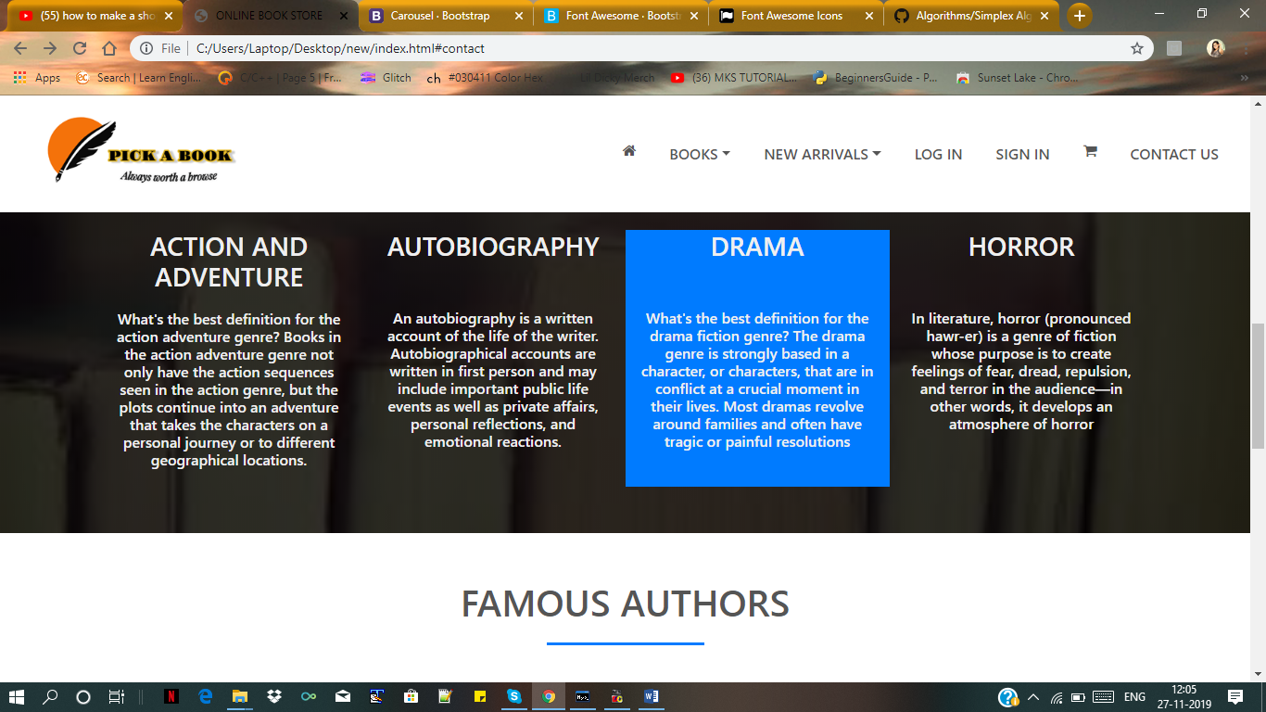

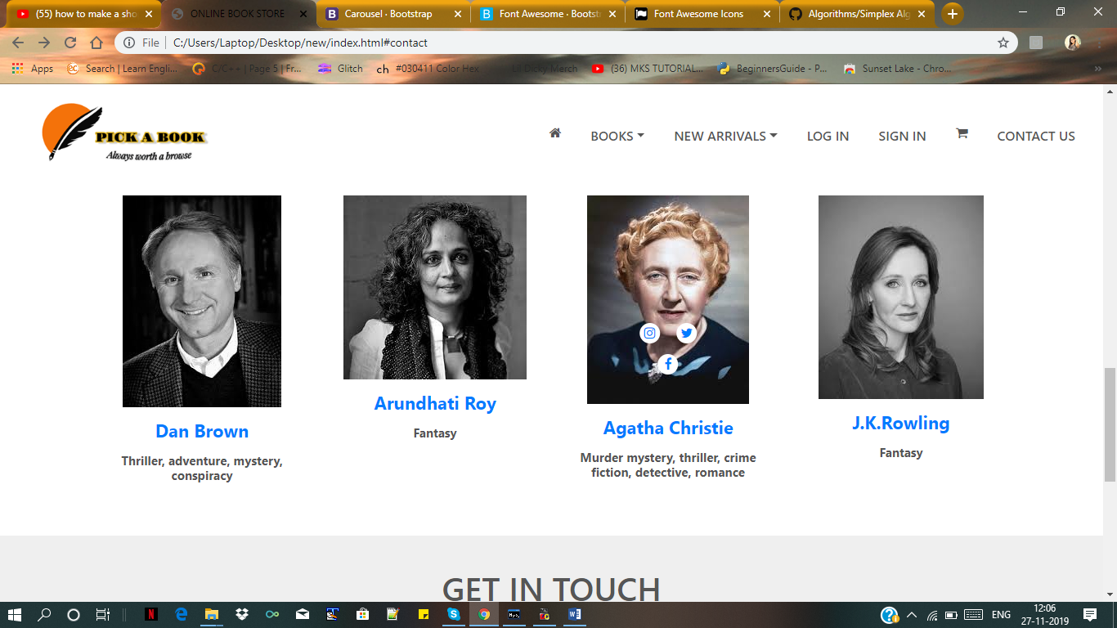

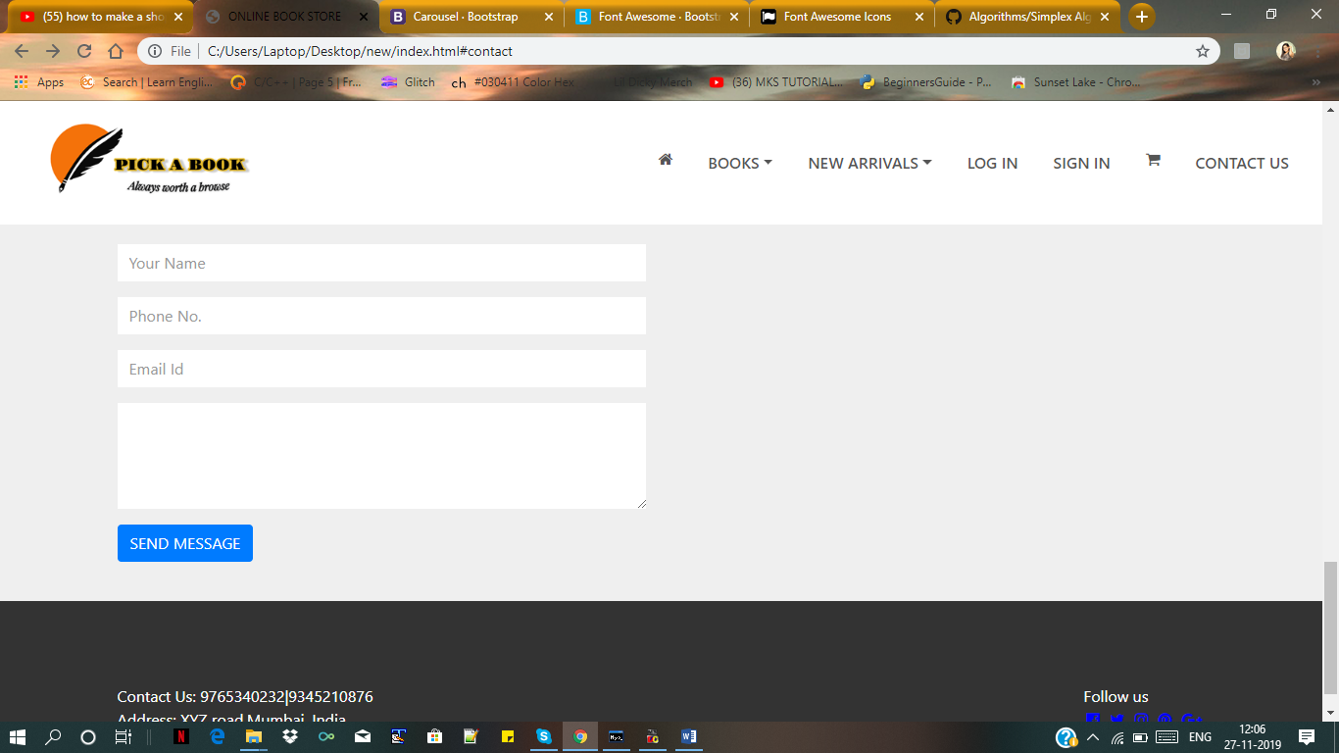

LOG IN

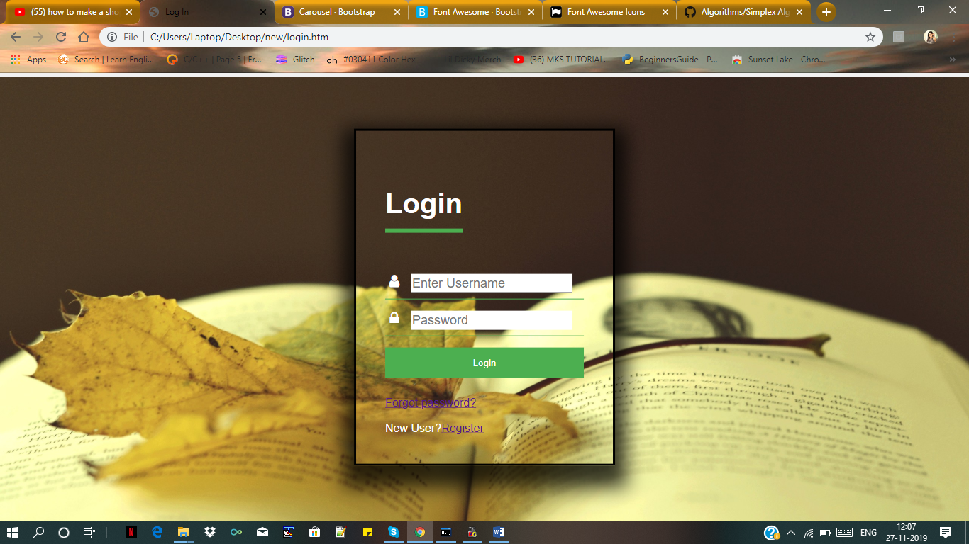

SIGN IN

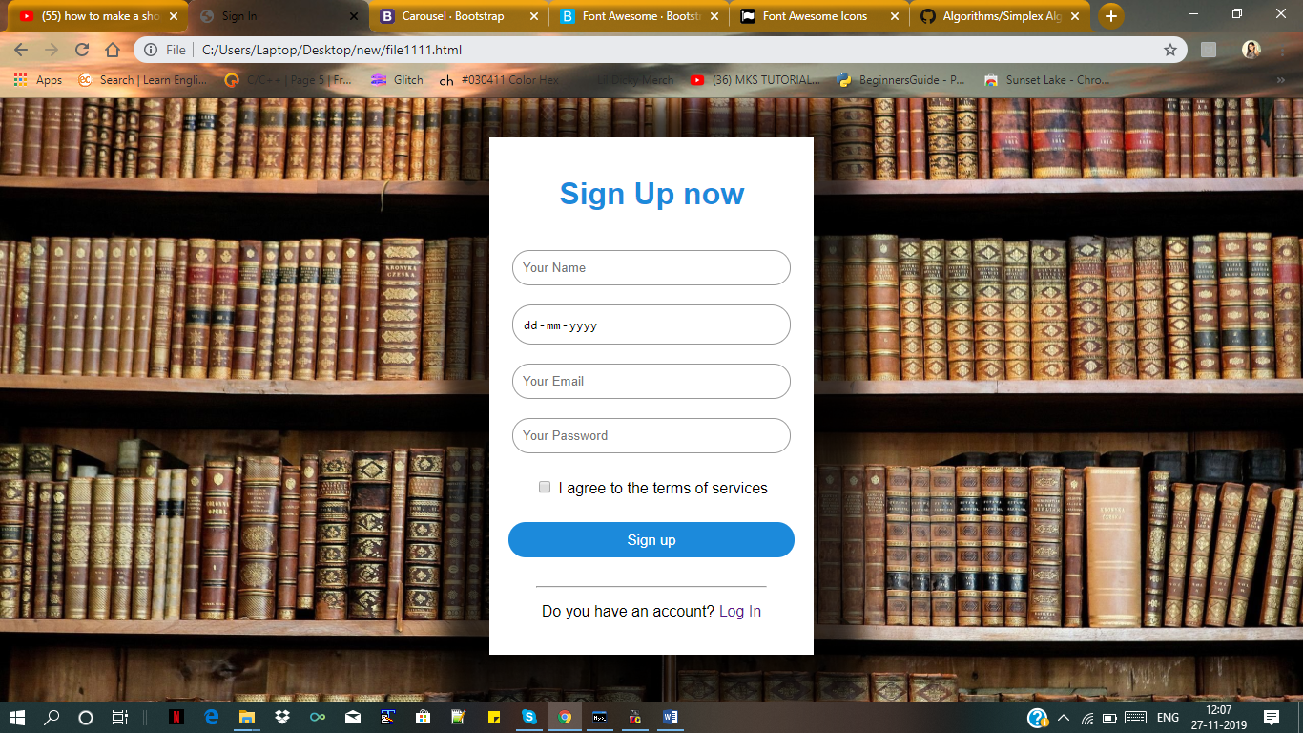

PAGE 1

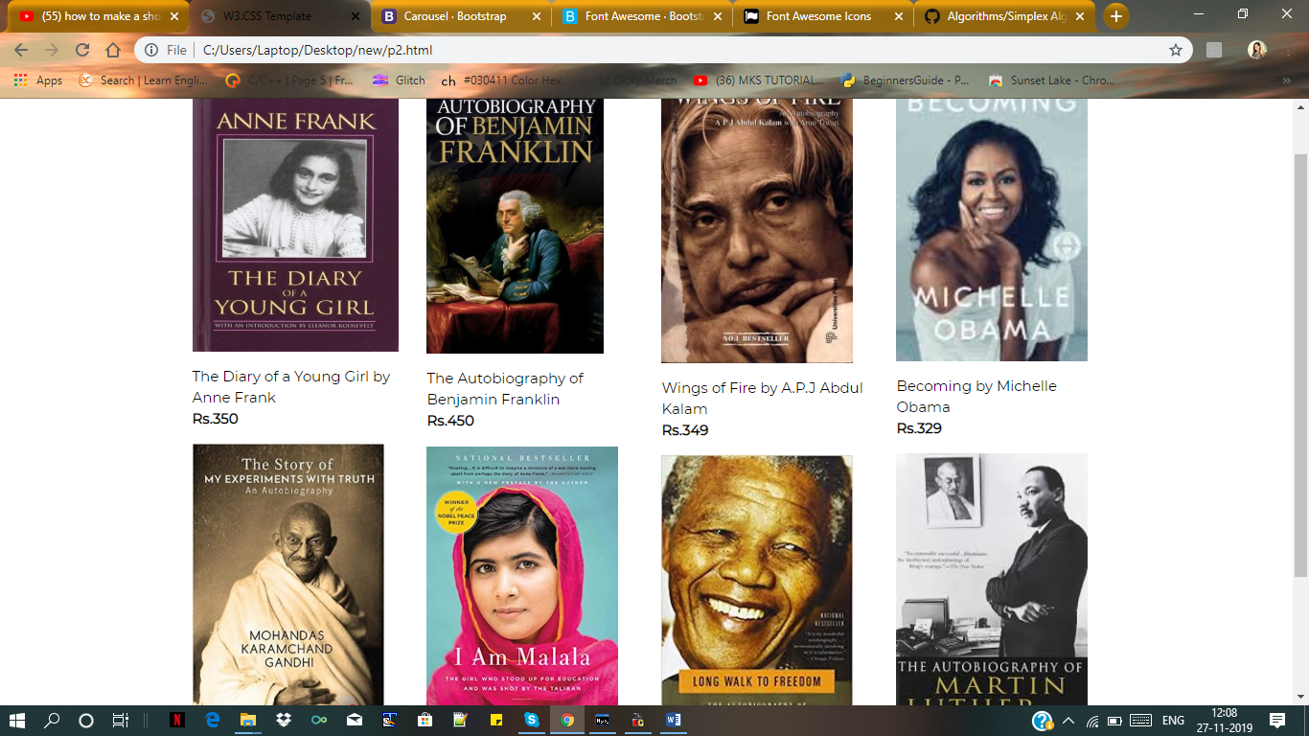

PAGE 2